
CODE OF CONDUCT 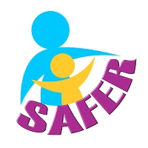

AS AN ADULT MEMBER I WILL

- Treat all children, young people and vulnerable adults with respect and dignity.
- Ensure that their welfare and safety is paramount at all times.
- Adhere to Safer Working Practices at all times
- Always act in an appropriate way and not accept bullying, swearing or other disruptive behaviour
- Liaise openly with parents, carers, coaches and all other members
- Listen to, and act upon, any disclosures, allegations or concerns of child abuse, the welfare of children or vulnerable adults.
- Attend Safeguarding training every 3 years
- Make activities FUN and enjoyable

Name: ……………………………………………………………

Signed: ……………………… Date………………………….
_____________________________________________________________

OR AS A YOUTH MEMBER I WILL

- Treat everyone as I would like to be treated
- Arrive on time with the correct clothes and equipment
- Help anyone as needed
- Be friendly, and respect all other members, coaches and volunteers
- Follow the rules
- Speak to coaches, volunteers or welfare officers, if I have any worries
- Join in with activities to have fun

Name: ……………………………………………………………..

Signed: …………………….. Date: ……………………..

